## Detailed Description

### Class Diagram

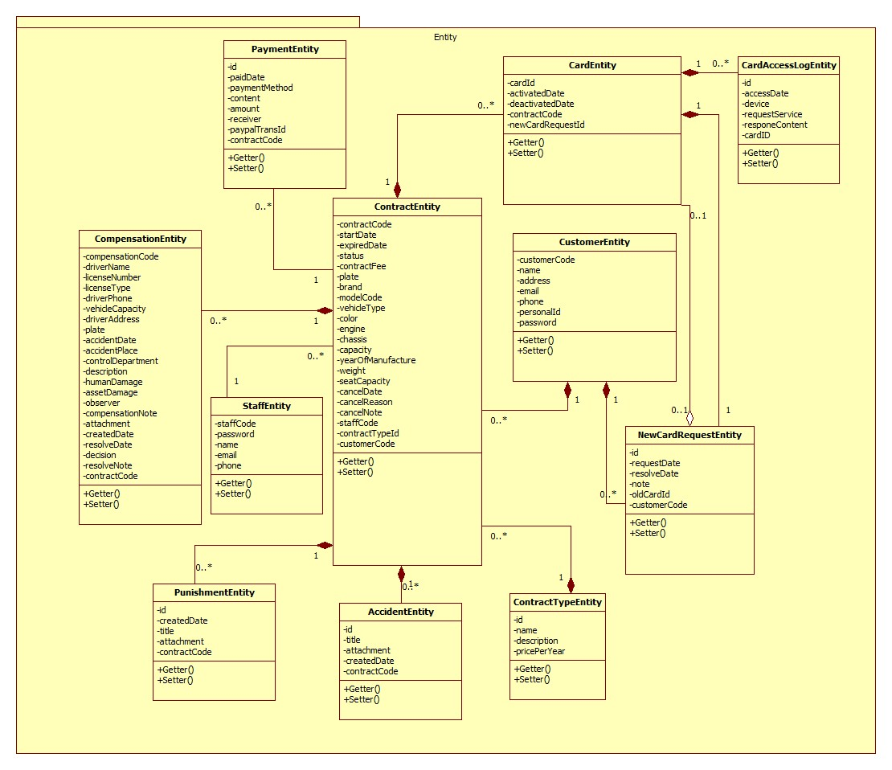

|  |  |
| --- | --- |
| **Class dictionary: describe Class** | |
| **Class Name** | **Description** |
| PaymentEntity | Contain the payment informations. |
| CardEntity | Contain the card informations. |
| CustomerEntity | Contain the customer informations. |
| ContractEntity | Contain the contract informations. |
| StaffEntity | Contain the staff informations. |
| CompensationEntity | Contain the compensation informations. |
| PunishmentEntity | Contain the punishment informations. |
| AccidentEntity | Contain the accident informations. |
| ContractTypeEntity | Contain the contract type informations. |
| NewCardRequestEntity | Contain the new card request informations. |
| CardAccessLogEntity | Contain the card access log informations. |

### Class Diagram Explanation

### PaymentEntity

|  |  |  |  |
| --- | --- | --- | --- |
| **Attribute** | **Type** | **Visibility** | **Description** |
| Id | int | Private | Unique identifier of an payment |
| paidDate | Timestamp | Private | The day process the payment |
| paymentMethod | String | Private | The payment method |
| content | String | Private | The content of the payment |
| amount | Double | Private | Total amount of the payment |
| receiver | String | Private | The payment receiver |
| paypalTransId | String | Private | The PayPal transaction ID |
| contractCode | String | Private | The contract code. |

|  |  |  |  |
| --- | --- | --- | --- |
| **Method** | **Return Type** | **Visibility** | **Description** |
| Getter | Attribute type | Public | Get attribute value. |
| Setter | Void | Public | Set value of attribute. |

### CardEntity

|  |  |  |  |
| --- | --- | --- | --- |
| **Attribute** | **Type** | **Visibility** | **Description** |
| cardId | String | Private | Unique identifier of an card |
| activatedDate | Timestamp | Private | The date the card was activated. |
| deactivatedDate | Timestamp | Private | The date the card was deactivated. |
| contractCode | String | Private | The contract code |
| newCardRequestId | String | Private | The new card request ID. |

|  |  |  |  |
| --- | --- | --- | --- |
| **Method** | **Return Type** | **Visibility** | **Description** |
| Getter | Attribute type | Public | Get attribute value. |
| Setter | Void | Public | Set value of attribute. |

### CustomerEntity

|  |  |  |  |
| --- | --- | --- | --- |
| **Attribute** | **Type** | **Visibility** | **Description** |
| customerCode | String | Private | Unique identifier of an customer |
| name | String | Private | Customer’s name. |
| address | String | Private | Customer’s address. |
| email | String | Private | Customer’s email. |
| phone | String | Private | Customer’s phone number. |
| personalId | String | Private | The customer’s personal ID. |
| password | String | Private | Customer’s password. |

|  |  |  |  |
| --- | --- | --- | --- |
| **Method** | **Return Type** | **Visibility** | **Description** |
| Getter | Attribute type | Public | Get attribute value. |
| Setter | Void | Public | Set value of attribute. |

### ContractEntity

|  |  |  |  |
| --- | --- | --- | --- |
| **Attribute** | **Type** | **Visibility** | **Description** |
| contractCode | String | Private | Unique identifier of a contract |
| startDate | Timestamp | Private | The start date of the contract. |
| expiredDate | Timestamp | Private | The expired date of the contract. |
| status | String | Private | The status of the contract. |
| contactFee | Double | Private | The contract fee. |
| plate | String | Private | The plate number of the motor. |
| brand | String | Private | The brand of the motor. |
| modelCode | String | Private | The model code of the motor. |
| vehicleType | String | Private | The vehicle type. |
| color | String | Private | The motor’s color. |
| engine | String | Private | The motor’s engine. |
| chassis | String | Private | The motor’s chassis. |
| capacity | String | Private | The motor’s capacity. |
| yearOfManufacture | int | Private | The year of manufacture. |
| weight | int | Private | The motor’s weight. |
| seatCapacity | int | Private | The seat capacity. |
| cancelDate | Timestamp | Private | The cancel date of the contract. |
| cancelReason | String | Private | The cancel reason. |
| cancelNote | String | Private | The cancel note. |
| contractTypeId | int | Private | The contract type ID. |
| customerCode | String | Private | The customer code. |

|  |  |  |  |
| --- | --- | --- | --- |
| **Method** | **Return Type** | **Visibility** | **Description** |
| Getter | Attribute type | Public | Get attribute value. |
| Setter | Void | Public | Set value of attribute. |

### StaffEntity

|  |  |  |  |
| --- | --- | --- | --- |
| **Attribute** | **Type** | **Visibility** | **Description** |
| staffCode | String | Private | Unique identifier of a staff |
| password | String | Private | The staff’s password |
| name | String | Private | The staff’s name. |
| email | String | Private | The staff’s email. |
| phone | String | Private | The staff’s phone number. |

|  |  |  |  |
| --- | --- | --- | --- |
| **Method** | **Return Type** | **Visibility** | **Description** |
| Getter | Attribute type | Public | Get attribute value. |
| Setter | Void | Public | Set value of attribute. |

### CompensationEntity

|  |  |  |  |
| --- | --- | --- | --- |
| **Attribute** | **Type** | **Visibility** | **Description** |
| compensationCode | String | Private | Unique identifier of a compensation |
| driverName | String | Private | The driver name. |
| licenseNumber | String | Private | The license number of the motor. |
| licenseType | String | Private | The license type of the motor. |
| driverPhone | String | Private | The driver’s phone number. |
| vehicleCapacity | String | Private | The vehicle capacity. |
| driverAddress | String | Private | The driver’s address. |
| plate | String | Private | The plate number. |
| accidentDate | Timestamp | Private | The accident date. |
| accidentPlace | String | Private | The accident place. |
| controlDepartment | String | Private | The police control department. |
| description | String | Private | The compensation’s description. |
| humanDamage | String | Private | The human damages. |
| assetDamage | String | Private | The asset damages. |
| observer | String | Private | The observer. |
| compensationNote | String | Private | The compensation note. |
| attachment | String | Private | The attachment. |
| createdDate | Timestamp | Private | The created date of the compensation. |
| resolveDate | Timestamp | Private | The resolve date. |
| decision | String | Private | The decision. |
| resolveNote | String | Private | The resolve note. |
| contractCode | String | private | The contract code. |

|  |  |  |  |
| --- | --- | --- | --- |
| **Method** | **Return Type** | **Visibility** | **Description** |
| Getter | Attribute type | Public | Get attribute value. |
| Setter | Void | Public | Set value of attribute. |

### PunishmentEntity

|  |  |  |  |
| --- | --- | --- | --- |
| **Attribute** | **Type** | **Visibility** | **Description** |
| id | int | Private | Unique identifier of a punishment |
| createdDate | Timestamp | Private | The created date. |
| title | String | Private | The title of the punishment. |
| attachment | String | Private | The attachment. |
| contractCode | String | Private | The contract code. |

|  |  |  |  |
| --- | --- | --- | --- |
| **Method** | **Return Type** | **Visibility** | **Description** |
| Getter | Attribute type | Public | Get attribute value. |
| Setter | Void | Public | Set value of attribute. |

### AccidentEntity

|  |  |  |  |
| --- | --- | --- | --- |
| **Attribute** | **Type** | **Visibility** | **Description** |
| id | int | Private | Unique identifier of an accident |
| title | String | Private | The title of the accident. |
| attachment | String | Private | The attachment. |
| createdDate | Timestamp | Private | The created date. |
| contractCode | String | Private | The contract code. |

|  |  |  |  |
| --- | --- | --- | --- |
| **Method** | **Return Type** | **Visibility** | **Description** |
| Getter | Attribute type | Public | Get attribute value. |
| Setter | Void | Public | Set value of attribute. |

### ContractTypeEntity

|  |  |  |  |
| --- | --- | --- | --- |
| **Attribute** | **Type** | **Visibility** | **Description** |
| id | int | Private | unique identifier of a contract type |
| name | String | Private | The contract’s name. |
| description | String | Private | The description. |
| pricePerYear | Double | Private | The price per year of the contract. |

|  |  |  |  |
| --- | --- | --- | --- |
| **Method** | **Return Type** | **Visibility** | **Description** |
| Getter | Attribute type | Public | Get attribute value. |
| Setter | Void | Public | Set value of attribute. |

### NewCardRequestEntity

|  |  |  |  |
| --- | --- | --- | --- |
| **Attribute** | **Type** | **Visibility** | **Description** |
| id | int | Private | Unique identifier of a new card request |
| requestDate | Timestamp | Private | The request date. |
| resolveDate | Timestamp | Private | The resolve date. |
| note | String | Private | The new card request note. |
| oldCardId | String | Private | The ID of the old card. |
| customerCode | String | Private | The customer code. |

|  |  |  |  |
| --- | --- | --- | --- |
| **Method** | **Return Type** | **Visibility** | **Description** |
| Getter | Attribute type | Public | Get attribute value. |
| Setter | Void | Public | Set value of attribute. |

### CardAccessLogEntity

|  |  |  |  |
| --- | --- | --- | --- |
| **Attribute** | **Type** | **Visibility** | **Description** |
| id | int | Private | Unique identifier of an card access log |
| accessDate | Timestamp | Private | The access date. |
| device | String | Private | The device name. |
| requestService | String | Private | The request service. |
| responseContent | String | Private | The response content. |

|  |  |  |  |
| --- | --- | --- | --- |
| **Method** | **Return Type** | **Visibility** | **Description** |
| Getter | Attribute type | Public | Get attribute value. |
| Setter | Void | Public | Set value of attribute. |

### Interactive Diagram

#### Web Application

Guest :

* Register new contract:

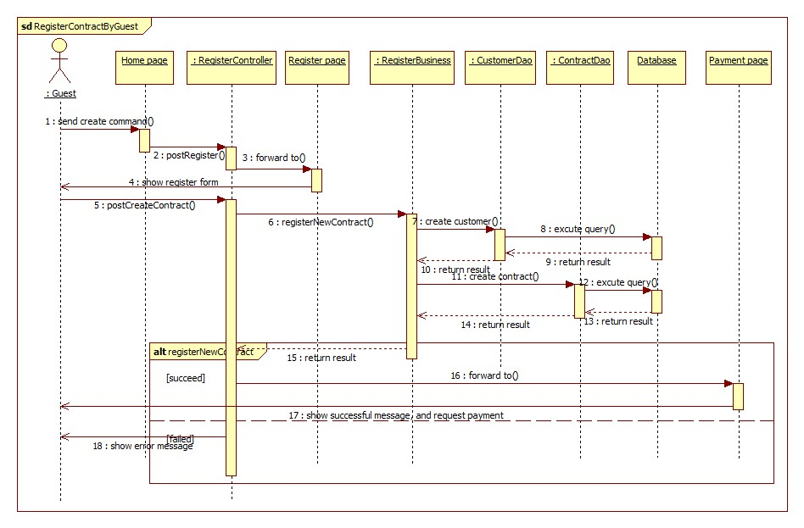

* PayPal payment:

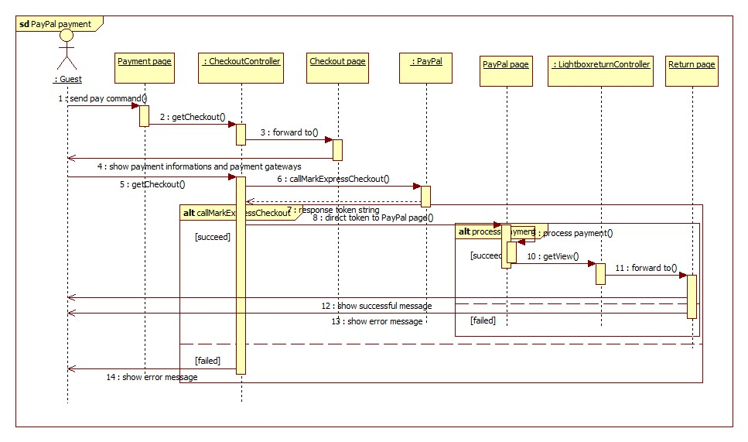

## Database design

### Logical database

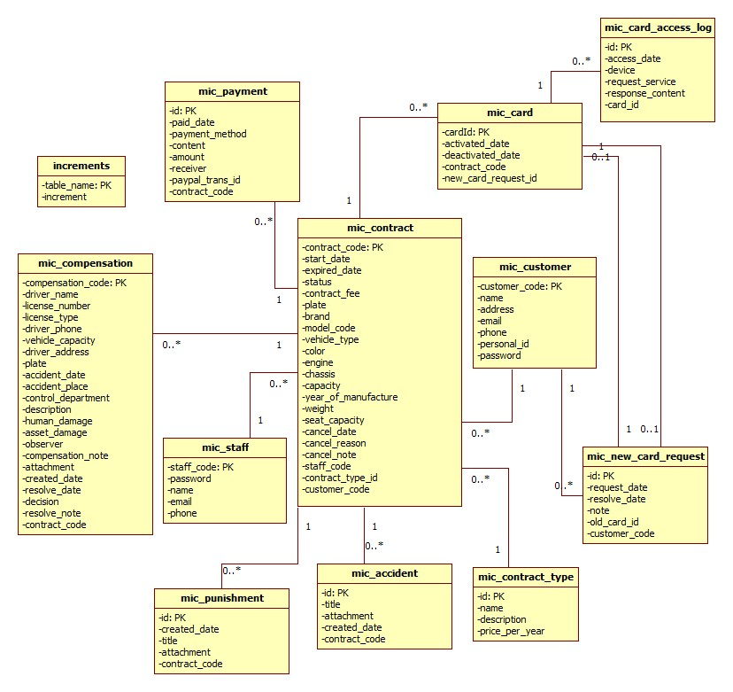

### Data Dictionary

|  |  |
| --- | --- |
| **Entity Data Dictionary: describe content of all entities** | |
| **Entity name** | **Description** |
| mic_customer | Contain the customer information. |
| mic_contract | Contain the contract information. |
| mic_card | Contain the card information. |
| mic_payment | Contain the payment information. |
| mic_staff | Contain the staff information. |
| mic_compensation | Contain the compensation information. |
| mic_punishment | Contain the punishment information. |
| mic_accident | Contain the accident information. |
| mic_contract_type | Contain the contract type information. |
| mic_new_card_request | Contain the new card request information. |
| mic_card_access_log | Contain the new card access log. |
| increments | Contain the number identity auto increment of other table (compensation, contract, customer, staff). |

|  |  |  |  |  |
| --- | --- | --- | --- | --- |
| **Entity Name** | **Attributes** | **Description** | **Domain** | **Null** |
| mic_customer | customer_code {PK} | Unique identifier of customer. | VARCHAR(10) | NO |
| name | Customer name | VARCHAR(80) | NO |
| address | Customer address | VARCHAR(250) | NO |
| email | Customer email | VARCHAR(250) | NO |
| phone | Customer phone number | VARCHAR(15) | NO |
| personal_id | Customer personal id. | VARCHAR(15) | YES |
| password | Customer password. | VARCHAR(32) | NO |
| mic_contract | contract_code {PK} | Unique identifier of contract. | VARCHAR(10) | NO |
| start_date | Start date of the contract | DATETIME | NO |
| expired_date | Expired date of the contract | DATETIME | NO |
| status | Contract’s status | VARCHAR(50) | NO |
| contract_fee | Contract’s fee. | FLOAT | NO |
| plate | Plate number of the motor. | VARCHAR(15) | NO |
| brand | Brand of the motor. | VARCHAR(20) | NO |
| model_code | Model code of the motor. | VARCHAR(20) | YES |
| vehicle_type | Vehicle type of the motor. | VARCHAR(20) | YES |
| color | Motor’s color. | VARCHAR(20) | YES |
| engine | Motor’s engine. | VARCHAR(20) | NO |
| chassis | Motor’s chassis | VARCHAR(20) | NO |
| capacity | Motor’s capacity. | VARCHAR(20) | NO |
| year_of_manufature | Year of manufacture. | INT UNSIGNED | YES |
| weight | Motor’s weight | INT UNSIGNED | YES |
| seat_capacity | Motor’s seat capacity. | INT UNSIGNED | YES |
| cancel_date | The contract cancel date. | DATETIME | YES |
| cancel_reason | The cancel reason. | VARCHAR(250) | YES |
| cancel_note | The cancel note. | VARCHAR(2000) | YES |
| staff_code | The staff code. | VARCHAR(10) | YES |
| contract_type_id | The contract type id. | INT UNSIGNED | NO |
| customer_code | The customer code. | VARCHAR(10) | NO |
| mic_card | card_id {PK} | The unique identifier of card. | VARCHAR(20) | NO |
| activated_date | The activated date of card. | DATETIME | NO |
| deactivated_date | The deactivated date of card. | DATETIME | YES |
| contract_code | The contract code | VARCHAR(10) | NO |
| new_card_request_id | The new card request id. | INT UNSIGNED | YES |
| mic_payment | id {PK} | The unique identifier of payment. | INT UNSIGNED | NO |
| paid_date | The date payment was processed. | DATETIME | NO |
| payment_method | The payment method | VARCHAR(20) | NO |
| content | The payment content. | VARCHAR(250) | NO |
| amount | The total amount. | FLOAT | NO |
| receiver | The receiver. | VARCHAR(80) | YES |
| paypal_trans_id | The paypal transaction id. | VARCHAR(50) | YES |
| contract_code | The contract code. | VARCHAR(10) | NO |
| mic_staff | staff_code | The unique identifier of staff. | VARCHAR(10) | NO |
| password | The staff password. | VARCHAR(32) | NO |
| name | The staff name | VARCHAR(80) | NO |
| email | The staff email. | VARCHAR(250) | NO |
| phone | The staff phone number. | VARCHAR(15) | NO |
| mic_compensation | compensation_code {PK} | The unique identifier of compensation | VARCHAR(10) | NO |
| driver_name | The driver name. | VARCHAR(80) | NO |
| license_number | The license number of the motor. | VARCHAR(15) | NO |
| license_type | The license type. | VARCHAR(10) | NO |
| vehicle_capacity | The vehicle capacity. | VARCHAR(20) | NO |
| driver_address | The driver’s address. | VARCHAT(250) | NO |
| plate | The plate number | VARCHAR(15) | NO |
| accident_date | The accident date. | DATETIME | NO |
| accident_place | The accident place. | VARCHAR)(250) | NO |
| control_department | The police control department. | VARCHAR(2000) | NO |
| description | The compensation description. | VARCHAR(2000) | NO |
| human_damage | The human damage. | VARCHAR(2000) | NO |
| asset_damage | The asset damage | VARCHAR(2000) | NO |
| observer | The observer name. | VARCHAR(80) | NO |
| compensation_note | The compensation note. | VARCHAR(2000) | YES |
| attachment | The attachment | VARCHAR(255) | YES |
| created_date | The created date of the compensation. | DATETIME | NO |
| resolve_date | The resolve date of the compensation | DATETIME | YES |
| desicion | The decision of the compensation | VARCHAR(250) | YES |
| resolve_note | The resolve note | VARCHAR(2000) | YES |
| contract_code | The contract code. | VARCHAR(10) | NO |
| mic_punishment | id {PK} | The unique identifier of punishment. | INT UNSIGNED | NO |
| created_date | The created date of the punishment. | DATETIME | NO |
| title | The punishment title | VARCHAR(250) | NO |
| attachment | The attachment file link. | VARCHAR(255) | NO |
| contract_code | The contract code. | VARCHAR(10) | NO |
| mic_accident | id {PK} | The unique identifier of accident. | INT UNSIGNED | NO |
| title | The accident title | VARCHAR(250) | NO |
| attachment | The attachment link file. | VARCHAR(255) | NO |
| created_date | The accident created date | DATETIME | NO |
| contract_code | The contract code | VARCHAR(10) | NO |
| mic_contract_type | id | The unique identifier of the contract type. | INT UNSIGNED | NO |
| name | The contract type name | VARCHAR(250) | NO |
| description | The contract type description | VARCHAR(2000) | NO |
| price_per_year | The price per year. | FLOAT | NO |
| mic_new_card_request | id | The unique identifier of new card request. | INT UNSIGNED | NO |
| request_date | The request date. | DATETIME | NO |
| resolve_date | The resolve date. | DATETIME | YES |
| note | The new card request note. | VARCHAR(2000) | NO |
| old_card_id | The card id of the old motor. | VARCHAR(20) | NO |
| customer_code | The customer code | VARCHAR(10) | NO |
| mic_card_access_log | id {PK} | The unique identifier of card access log. | INT UNSIGNED | NO |
| access_date | The access date. | DATETIME | NO |
| device | The access device. | VARCHAR(50) | NO |
| request_service | The request service. | VARCHAR(200) | NO |
| response_content | The response content. | VARCHAR(200) | NO |
| card_id | The card id. | VARCHAR(20) | NO |
| increments | table_name | The unique identifier of the increments table. | VARCHAR(255) | NO |
|  | increment | The auto increment number of other table (staff, contract, customer, compensation) | INT | YES |